Legi-Air 4050B-EL
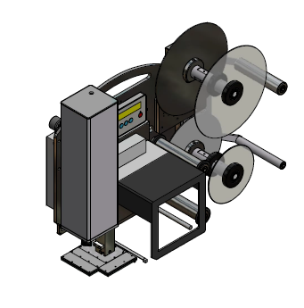 |  | Technical Specifications:
 |  | Printing Technology  Print Resolution  Print Speed | Thermal transfer  or direct thermal
8 dots / mm (203 dpi)
12 dots / mm (300 dpi)
24 dots / mm (600dpi)
 |  |  | Up to 400 mm per second
 |  | Label Size | Tamp-Blow Standard from 12,5 x 7 to  120x160mm/160x120mm, depending on label qualitiy the label length is limited
 |  | Tamp Sizes | -
 |  | Label Gap  Label Roll | minimum 3 mm
300 mm outside diameter up to 450 rm, core 76mm (3“),
outside winding
optional: inside winding
 |  | Data Interface | All current interfaces  (details in prospect print engines)
 |  | Controller Interface | Volt free outputs (relays),  opt coupler inputs,  M12 connector for photocell and alarm lamp
 |  | Maintenance Interval | According to interval display
 |  | Performance Data | Up to 70 labels per minute, performance data depends on label size, text change and stroke
 |  | Application Accuracy | Standard: up to ± 1 mm on stopped product (depending on application distance,  and label size)
 |  | Print-Apply-Trigger | Reflex sensor,  light barrier,  inductive or capacitive sensor,  micro switch,  volt free contact (PLC)
 |  | Alarm System | Standard: LED error message in text display, volt free contact (PLC),  optional: 3-coloured alarm lamp
 |  | Compressed Air Consumption  Compressed Air Connection | 0,3 up to 3 l per applying cycle, depending on label size, type of applicator and setting
6 bar,
Compressed air has to be dry and oil-free
(DIN ISO 8573-1)
 |  | Weight | Up from 35 kg  (depending on version)
 |  | Power Connection | 91 up to 263 VAC,  50/60 Hz,  5 Ampere
 |  | Environmental Conditions | Temperature: 10° C up to 35° C,  2 up to 95 % relative air humidity,  non-condensing
 |  | Certification | CE-Declaration of Conformity
 |  | Options | 3-coloured alarm lamp  IPC in protective housing  LLS Legitronic® Labeling Software  Bluhmware for controlling and networking the systems  attendance check of labels  Product sensors  sensor for variable stroke  stands in different versions (fixed, adjustable via spindle, mobile)
 |  | Applicators | linear stroke 250mm with stepper motor
 |  | Dimensions
Distribution arguments depending on system

- print engine technology of leading global manufacturers
- all moving applicators are driven by stepper motor
- Europe-wide distribution
- very compact construction with a large spectrum of enhancement
- developed for day and night operation
- all components and also spare parts are standard and originated from large-volume production
- simple and well-arranged system structure enables the customer`s technicians quick self-help measures in case of errors
- large consultant and service network

 | Technical Specifications (in detail):
 | Base Plate | 10 mm aluminum anodised
 | Housing of Applicator Controller | anodised aluminum profile tube
 | Housing of Print Engine Connections | -
 | Cabinet without fan | -
 | Festo Pneumatics | 0%
 | Gauge | -
 | Mechanical Components | metric
 | Modules / Replacement-Assemblies | standard
 | Display Lighting | aluminum anodised
 | (Remote) Display  Remote mountable | standard
 | Display turnable | user-defined
 | Multilingual Display-Menu | EN, DE, FR, NL, NO, SE, RU, PL, ES, TR, PT, IT, CZ, HR, Optional: AZ, FI, HU, LV
 | Detailed Status and Error Messages | standard
 | Diagnostic Function  Diagnosis Monitor | via display and USB
 | Adjustable cycle time of valves | in 1 ms steps
 | Service/Maintenance Counter  Service Message | yes, display message + volt free contact
 | Variants of Applicator | 1
 | Printer | flexible print engine technique:  Datamax,  Sato,  Zebra,  Avery,  CAB
 | LH / RH | yes, at the same price
 | Max. Tamp (mm) | 20000mm² or 200mm long or 160mm wide
 | Max. Label (mm) | 20000mm² or 200mm long or 160mm wide
 | Min. Tamp (mm) | 10 x 5
 | Min. Label (mm) | 10 x 5
 | Max. Stroke (useable) | 200 mm
 | Max. Stroke (useable; optional) | -

 | Recommended continuous power rating with max. stroke standard applicator  PPM=products per minute |  | 3-shift, because of robust applicator construction no limitation for continuous operation
 | Top performance with max. stroke  standard applicator |  | no difference to continuous rating
 | Top performance with KH High Speed Unit  (small label, min. stroke) |  | -
 | Top performance with Blow Box |  | < 70 per min
 | Tolerance of Label Position  (standard applicator) |  | ± 1mm
 | Tolerance of Label Position  (precision applicator) |  | -
 | Tolerance of Label Position  (Wipe-on mode) |  | -
 | Alarm Lamp  M12 connector |  | standard
 | 1st Product Sensor  M12 connector |  | standard
 | 2nd Product Sensor  M12 connector |  | standard
 | Product Sensor configuration NPN/PNP |  | via display
 | Possibilities of configuration via PC |  | standard / USB
 | Signal exchange to customer via volt free contact |  | standard
 | Max. Roll Diameter |  | 300 mm
 | Max. Run Width |  | 160 mm  optional: 173 mm
 | Unwind Discs |  | standard
 | Rewind  (stepper motor technique) |  | standard
 | Quick Change |  | option
 | Variable Product Detection |  | option
 | Low Label Prewarning |  | option
 | Control Label on Tamp Pad |  | standard
 | 2-level Vacuum |  | -
 | Service – Export Possibility |  | D, A, CH, B, DK, NL, F, E, I, P, UK, IRL, N, S
 | Possibility to save and recall label data in the labeler |  | -
Weiter Optionen:

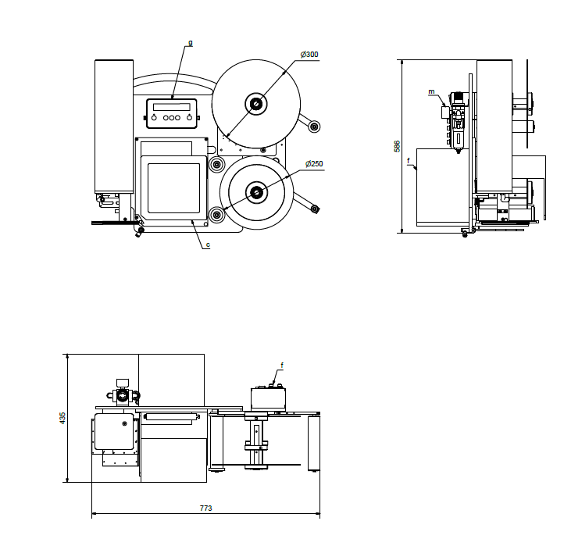

Stativadapter-4050B 40087593
- Alternative to the stand. U-arm
- Dimensions and angle of inclination in the drawing
- Projection: 330mm
- Angle of inclination: +-7,5°.
