Legi-Air 4050WO
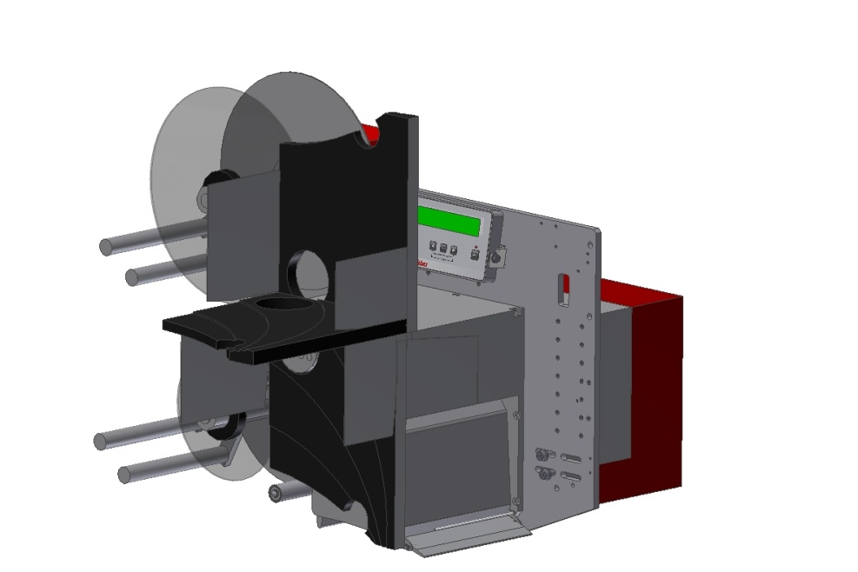 |  | Technical Specifications:
 |  | Printing Technology  Print Resolution  Print Speed | Thermal transfer
 |  |  | 12 dots / mm (300 dpi)
 |  |  | Up to 400 mm per second
 |  | Label Size | 14 x 20 mm  up to 173 x 1000mm
 |  | Dispensing Speed | Up to 24m / min
 |  | Label Gap  Label Roll | minimum 3 mm
300 mm outside diameter up to 450 rm,
core 76 mm (3“),
outside winding,
optional: inside winding
 |  | Data Interface | RS23,  Parallel,  USB,  Ethernet
 |  | Controller Interface | Volt free outputs (relays),  opt coupler inputs,  M12 connector for photocell and alarm lamp
 |  | Maintenance Interval | According to interval display
 |  | Performance Data | Up to 250 labels per minute,  performance data depends on label size, text change and product speed and operation mode
 |  | Application Accuracy | ± 0,8 mm
 |  | Print-Apply-Trigger | Reflex sensor,  light barrier,  inductive or capacitive sensor,  micro switch,  volt free contact (PLC)
 |  | Alarm System | Standard: LED error message in text display, volt free contact (PLC),  optional: 3-coloured alarm lamp
 |  | Weight | Up from 35 kg  (depending on version)
 |  | Power Connection | 90 up to 263 VAC,  50/60 Hz,  5 Ampere
 |  | Environmental Conditions | Temperature: 5° C up to 35° C,  15 up to 95 % relative air humidity,  non condensing
 |  | Certification | CE-Declaration of Conformity
 |  | Options | 3-coloured alarm lamp  Low label prewarning  IPC in protective housing  LLS Legitronic® Labeling Software  Bluhmware for controlling and networking the systems  attendance check of labels  Scanner (1-D/2-D),  Vision Systems,  Sensors,  RFID Gates product sensors  stands in different versions (fixed, adjustable via spindle, mobile)
 |  | Applicator | Wipe on
 |  | Dimensions | 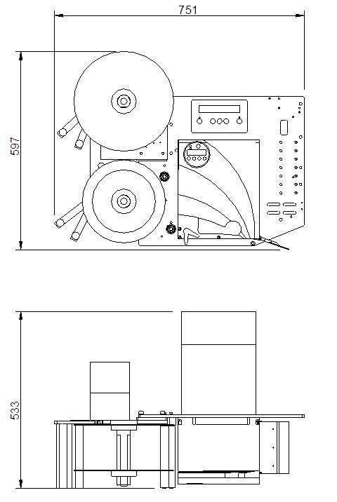 -
Distribution arguments depending on system

- low priced print and apply system
- labeling 1:1 to printing
- no compressed air
- large label rolls 300 mm diameter
- precise peeling
- all components and also spare parts are standard and originated from large-volume production
- simple and well-arranged system structure enables the customer`s technicians quick self-help measures in case of errors
- large consultant and service network

 | Technical Specifications (in detail):
 | Base Plate | 10 mm aluminum anodised
 | Length of Standard Peeler Blade (mm) | 50
 | Housing of Print Engine Connections | -
 | Cabinet without fan | -
 | Mechanical Components | metric
 | Modules / Replacement-Assemblies | standard
 | Display Lighting | -
 | (Remote) Display  Remote mountable | -
 | Display turnable | user-defined
 | Multilingual Display-Menue | EN, DE, FR, NL, NO, SE, RU, PL, ES, TR, PT, IT, CZ, HR, Optional: AZ, FI, HU, LV
 | Detailed Status and Error Messages | standard
 | Diagnostic Function  Diagnosis Monitor | via display and  USB / Ethernet software
 | Change Peeler Blade | option
 | Service/Maintenance Counter  Service Message | yes, display message + volt-free contact
 | Micro switch Label Detection | option
 | Printer | Avery DPM
 | LH / RH | yes, at the same price
 | Max. length of peeler blade (mm) | 200
 | Max. label (mm) | 160 x 1000  optional: 173 x 1000
 | Label processing 1:1 | possible  (caution: application rate)
 | Min. label (mm) | 14 x 10
 | Top speed of peeling (with limitation regarding label size) | 24m / min
 | Label cache between printer and peeler blade | length of peeler blade +  19 mm
 | Recommended continuous power rating with max. stroke  Standard applicator  PPM=products per minute | 3 shifts,  no limitation for continuous operation
 | Mechanical adaption in case of changing label size | -
 | Tolerance of label position | ± 0,8 mm
 | Alarm lamp  M12 connector | standard
 | 1st Product Sensor  M12 connector | standard
 | Shaft encoder  M12 connector | -
 | Product sensor configuration NPN/PNP | via USB
 | Possibilities of configuration via PC | standard / USB / Ethernet
 | Signal exchange to customer via volt free contact | standard
 | Max. Roll Diameter | 300 mm
 | Max. Run Width | 160 mm  (optional 173)
 | Unwind Discs | standard
 | Rewind  (stepper motor technique) | standard
 | Low Label Prewarning | option
 | Service – Export Possibility | D, A, CH, B, DK, NL, F, E I, P, UK, IRL, N, S
 | Possibility to save and recall label data in the labeler | -

