Legi-Air 4050I
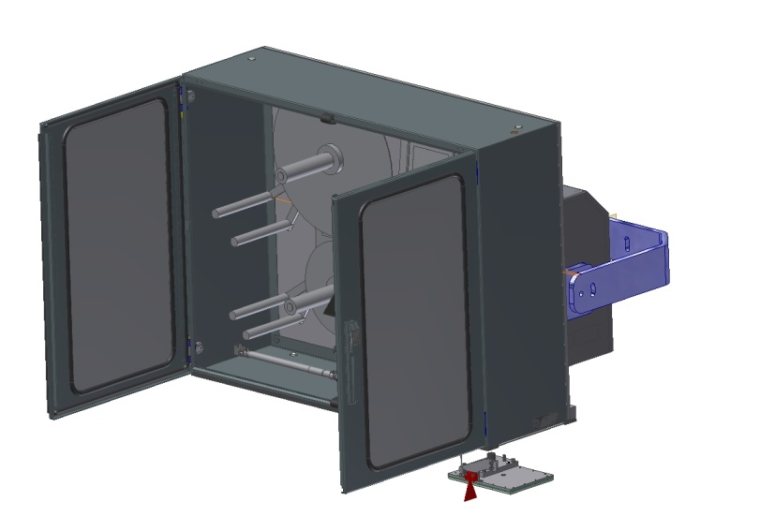 | Technical Specifications:
 | Printing Technology  Print Resolution  Print Speed | Thermal transfer  or direct thermal
9 dots / mm (203 dpi)
12 dots / mm (300 dpi)
24 dots / mm (600 dpi)
 |  | Up to 400 mm per second
 | Label Size | Tamp-Blow Standard from  12,5 x 7 mm up to 150 x 210 mm,  depending on label quality the label length is limited,  considerable larger or smaller labels are possible with nonstandard tamps
 | Tamp Size | -
 | Label Gap  Label Roll | minimum 3 mm
300 mm outside diameter up to 450 rm, core 76mm (3“),
outside winding,
low label prewarning,
optional: inside winding,
larger cores and 350 mm outside diameter label roll
 | Data Interface | All current interfaces  (details in prospect print engines)
 | Controller Interface | Volt free outputs (relays),  opt coupler inputs,  M12 connector for photocell and alarm lamp
 | Maintenance Interval | According to interval display
 | Performance Data | Up to 100 labels per minute,  performance data depends on label size, text change and stroke
 | Application Accuracy | Standard: up to ± 0,8 mm on stopped product (depending on application distance,  type of applicator and label size)  optional: ± 0,5 mm
 | Print-Apply-Trigger | Reflex sensor,  light barrier,  inductive or capacitive sensor,  micro switch,  volt free contact (PLC)
 | Alarm Device | Standard: LED error message in text display, volt free contact (PLC),  optional: 3-coloured alarm lamp
 | Compressed Air  Compressed Air Connection | 0,3 up to 3 l per applying cycle  depending on label size, type of applicator and setting
6 bar,
Compressed air has to be dry and oil-free
(DIN ISO 8573-1)
 | Weight | Up from 120 kg  (depending on version)
 | Power Connection | 92 up to 263 VAC,  50/60 Hz,  5 Ampere
 | Environmental Conditions | Temperature: 2° C up to 35° C,  15 up to 95 % relative air humidity,  non-condensing  protective cabinet against dust for very difficult environmental conditions protects the printer
 | Certification | CE-Declaration of Conformity
 | Options | RFID labelling  QC Quick Change Tamp  spring loaded Tamp  3-coloured alarm lamp  Automatic shutter  heating  IPC in protective housing  LLS Legitronic® Labeling Software  Bluhmware for controlling and networking the systems attendance check of labels  scanner (1-D/2-D),  Vision Systems,  Sensors,  RFID Gates  Product Sensors  sensor for variable stroke stands in different versions (fixed, adjustable via spindle, mobile)
 | Applicators | One side pallet labeler with extra-large stroke  Linear stroke up to 1200mm stroke  KH High Speed linear applicator  Linear applicator  Servo applicator
 | Dimensions | -

Distribution arguments depending on system

- print engine technology of leading global manufacturers
- very good protection against harsh environmental conditions
- Europe-wide distribution
- very compact construction with a large spectrum of enhancement
- developed for day and night operation
- all components and also spare parts are standard and originated from large-volume production
- simple and well-arranged system structure enables the customer`s technicians quick self-help measures in case of errors
- large consultant and service network

 | Technical Specifications (in detail):
 | Base Plate | 10 mm aluminum anodised  (on request 14 mm)
 | Housing of Applicator Controller | stainless steel
 | Housing of Print Engine Connections | stainless steel
 | Cabinet without fan | standard
 | Festo Pneumatic | 100%
 | Gauge | 2 internal
 | Mechanical Components | metric
 | Modules / Replacement-Assemblies | > 50 %
 | Display Lighting | background lighting
 | (Remote) Display  Remote mountable | standard
 | Display turnable | user-defined
 | Multilingual Display-Menue | EN, DE, FR, NL, NO, SE, RU, PL, ES, TR, PT, IT, CZ, HR, Optional: AZ, FI, HU, LV
 | Detailed Status and Error Messages | standard
 | Diagnostic Function  Diagnosis Monitor | via display  USB / Ethernet software
 | Adjustable cycle time of valves | in steps of 1 ms
 | Service/Maintenance Counter  Service Message | yes, display message + volt free contact
 | Variants of Applicator | several hundred variants
 | Printer | flexible print engine technology:  Datamax,  Sato,  Zebra,  Avery,  CAB
 | LH / RH | yes, at the same price
 | Max. Tamp (mm) | 150 x 210
 | Max. Label (mm) | 150 x 210
 | Min. Tamp (mm) | 10 x 5
 | Min. Label (mm) | 10 x 5
 | Max. Stroke (useable) | -
 | Max. Stroke (useable; optional) | 1085 mm
 | Recommended continuous power rating with max. stroke standard applicator  PPM=products per minute | 3-shift, because of robust applicator construction no limitation for continuous operation
 | Top performance with max. stroke  standard applicator | no difference to continuous rating
 | Top performance with KH High Speed Unit  (small label, min. stroke) | 100 per min
 | Top performance with Blow Box | -
 | Tolerance of Label Position  (standard applicator) | ± 0,8 mm
 | Tolerance of Label Position  (precision applicator) | ± 0,5 mm
 | Tolerance of Label Position  (Wipe-on mode) | -
 | Alarm Lamp  M12 connector | standard
 | 1st Product Sensor  M12 connector | standard
 | 2nd Product Sensor  M12 connector | standard
 | Product Sensor configuration NPN/PNP | via display
 | Possibilities of configuration via PC | standard / USB / Ethernet
 | Signal exchange to customer via volt free contact | standard
 | Max. Roll Diameter | 300 mm  optional: 350 mm
 | Max. Run Width | 160 mm
 | Unwind Discs | standard
 | Rewind  (stepper motor technique) | standard
 | Quick Change | option
 | Variable Product Detection | option
 | Low Label Prewarning | standard
 | Control Label on Tamp Pad | standard
 | 2-level Vacuum | standard
 | Service – Export Possibility | D, A, CH, B, DK, NL, F, E, I, P, UK, IRL, N, S
 | Possibility to save and recall label data in the labeler | -

